Beginning C++ Programming - From Beginner to Beyond
QUIZ 1
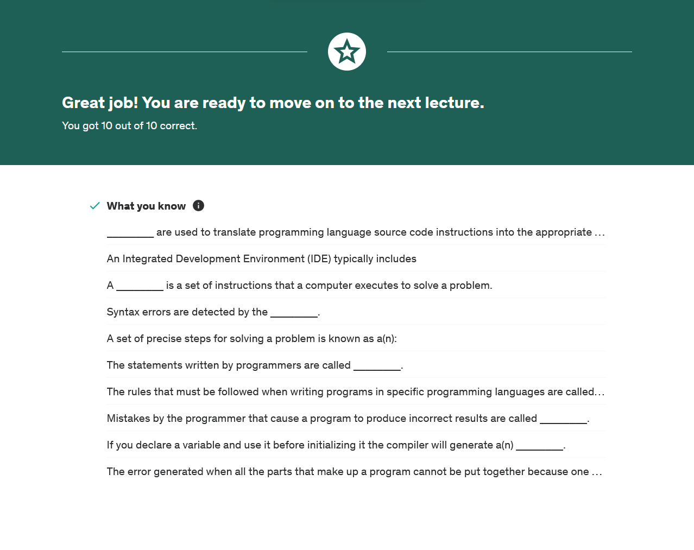
Liner Error
Warning
Logic Errors
Syntax

Algorithm
Compiler
Program
Debugger, Text Editor & Compiler
Compiler

QUIZ 2


   

